Fluorescin Strips Ophthalmic Strips
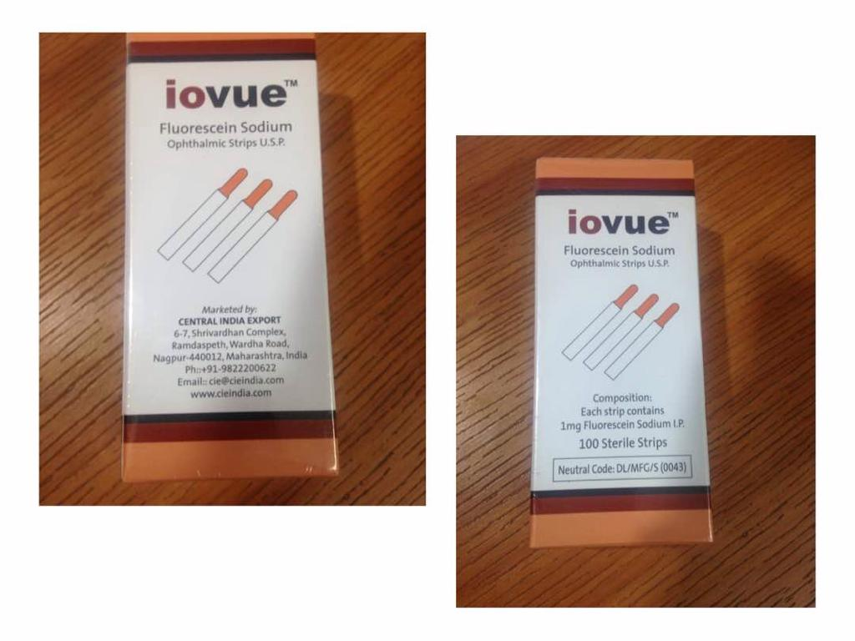Quick Enquiry
Fluorescein Strips are specially prepared sterile ophthalmic strip meant for diagnostic use to visualize abrasions and defects on the corneal epithelium by staining the area of the cellular loss. It is especially meant for staining the anterior segment of the eye while determining the site of an ocular injury, also useful for placing the contact lenses fitting, applanation tonometry and while taking the lacrimal drainage test. It is available in a box of 100 strips in an individual pouch pack.

